CORVAIR TRACK CLASSIC
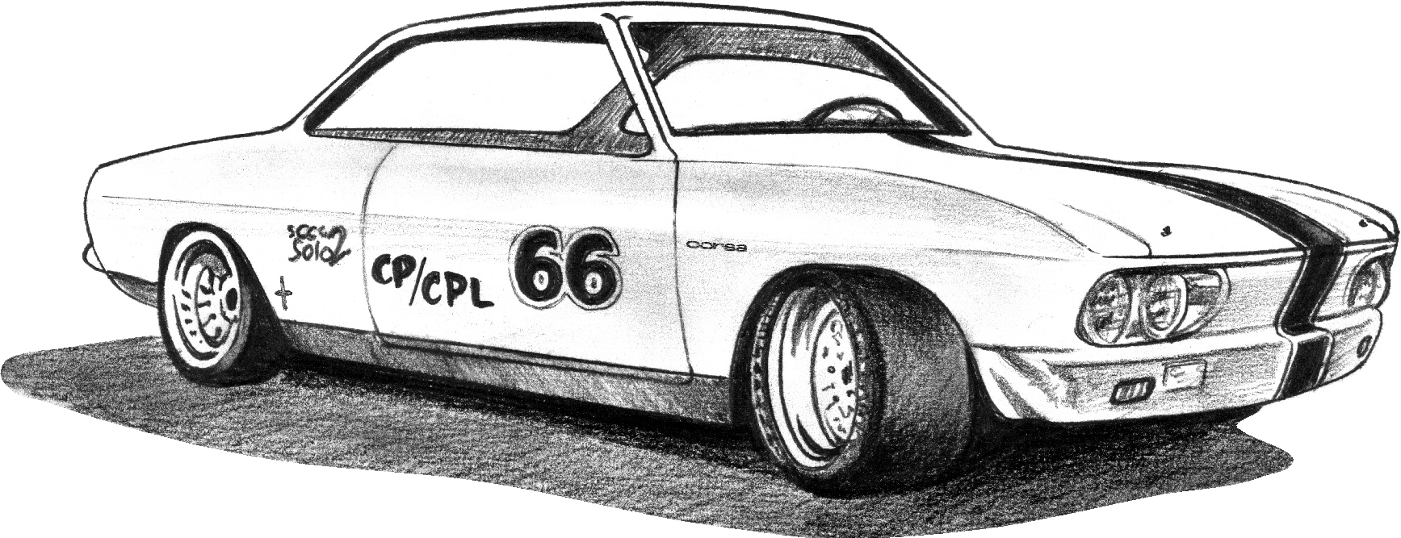
Hosted by Shade’s Classic Corvairs Hastings, Nebraska

SCHEDULE OF EVENTS, 2015 as of 1/27/15
* All Road Course racing results will be posted immediately via www.race-monitor.com *

Friday, August 28:
6:30-9:00pm – Welcome Party at Shade’s Classic Corner featuring a meet & greet with our special guest Lynn Yenko! Heavy “Nebraska” hors d’oeuvres and refreshments (non-alcoholic).

Saturday, August 29:
7:00am – MPH opens
7:30am – Tech Inspection @ MPH
8:30am – Driver meeting with MPH staff
9:00am – Practice laps on Full Road Course
10:30am – Competitive Timed Racing begins
12-1:00pm – Lunch (in MPH Clubhouse, Provided for all drivers with paid entry fee. Catered from Valentino’s including: salad, pizza and/or lasagna, etc)
1:00-4:00pm – Timed Racing continues
4:15-5:30pm -1/8 Drag/”Grudge” racing (you pick whom you run)
6:30pm - “Throw-Back” BBQ and Car Show (featuring the Corvair) @ Chautauqua Park (4th & Laird), Hastings, NE 68901) and awards. Lynn Yenko is again our featured guest and the Corvair our featured car. We request that each Corvair participant and their families attend and bring their car to enjoy some food, fun and fellowship as we promote the Corvair at this FREE all-city event. The local classic car club ("Melonroasters") will be sponsoring and assisting with the event.
Sunday, August 30:
8:00am – MPH opens
8:30am – Driver meeting with MPH staff
9:00am - Autocross Racing begins
1:00pm – Racing concludes and awards
