CORVAIR TRACK CLASSIC
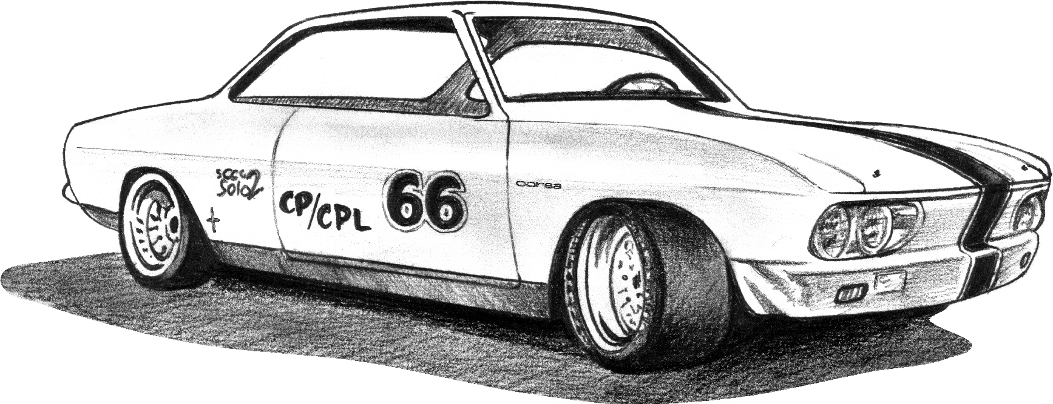
Hosted by Shade’s Classic Corvairs Hastings, Nebraska

SS1 ’60-’64 Low Performance (80-110hp) SS2 ’62-’64 High Performance (150hp)
SS3 ’65-’69 Low Performance (95-110hp) SS4 ’65-’69 High Performance (140-180hp)
SS5 – All Forward Controls
IS1 ’60-’64 Low Performance IS2 ’65-’69 Low Performance
IS3 ’60-’69 (140-150-180hp) IS4 ’61-’65 FC

IS5 Improved stock Corvairs with ‘R’ tires or less than 180 wear ratings
SM, SM2 Corvairs with V6 or V8 CC (Competition Class)
Ladies Low Performance / Ladies High Performance

NAME: ___________________________________
ADRESS: ____________________________ CITY: __________________
STATE: _____________________ CELL #: ( ) _____ - ______________
EMAIL: ______________________________________________________

CAR CLASSIFICATION: ____________
If your car has a permanent number, list it here _________
Note: Permanent car numbers will only be honored for cars that are pre-registered

__________________________________ ____/____/____
Signature Date
By my signature on this form, I hereby declare that the Club sponsors and all of its officers/sponsor, Motorsport Park Hastings, and the organizers of this event will not be reponsible for any accidents to any person or property.

Please return completed form to “Shade’s Classic Corvairs” at 1016 South Burlington, Hastings, NE 68901. Please make checks payable to “Corvair Track Classic”

Entry Fees
August 29 (Saturday): FULL ROAD COURSE 9:00am – 4:00pm
$179 individual event or $249 for both days (all 3 events) prior to April 30, 2015
$189 individual event or $279 for both days (all 3 events) prior to July 31, 2015
$199 individual event or $299 for both days (all 3 events) up to race day
August 29 (Saturday): 1/8 “GRUDGE”/DRAG RACING 4:15pm – 5:30pm
$25 individual event prior to April 30, 2015
$30 individual event prior to July 31, 2015
$35 individual event up to race day
August 30 (Sunday): AUTOCROSS 9:00am – 1:00pm
$89 individual event prior to April 30, 2015
$99 individual event prior to July 31, 2015
$119 individual event up to race day

