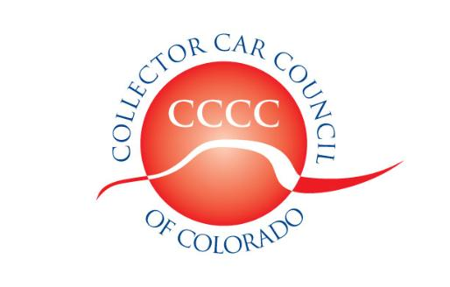

Collector Car Council of Colorado, Inc.

Dedicated to the preservation of automotive history

www.collectorcarcouncil.com 720-535-6097

President: Dick Thompson, Mile High Cobra Club 303-699-4819 Thompson660@cs.com
1st Vice Pres: Tom Mansfield, Looking Glass Corvette 720-344-7143 tommans@outlook.com
2nd Vice Pres: Samantha Baker, So.Colo.MOPAR 303-726-2826 Bakersams@msn.com
Secretary: Dick Fritz, MG Car Club 303-774-9710 RBFritz@comcast.net
Treasurer: Tom Kay, Front Range Mustang Club 303-451-9296 TomKay1167@gmail.com
Legislative information: Leo J. Boyle 303-321-6611 Leojboyle@aol.com
Colorado Collector Car News: Greg Akiyama 303-680-8298 gakiyama@earthlink.net
Political Committee Liaison: Ted Rossi 303-618-3935 Tedrossi@q.com

Minutes of Meeting, 3 January 2018
The meeting was held at the Forney Transportation Museum, 4303 Brighton Blvd., Denver Colorado.

Prior to the CCCC meeting, the Forney opened the display area for viewing by club representatives.

The meeting was called to order at 7:30 pm by First Vice President Tom Mansfield. Officers in attendance were Tom Mansfield, 1st V.P.; Samantha Baker, 2nd V.P.; Dick Fritz, secretary; and Tom Kay, treasurer. President Dick Thompson was absent but with a good excuse. He was trying to recruit a new club. 39 member clubs were represented and two individual members were in attendance.

Guest speakers: William Taylor of Auto Archives and Sara Bain from Hagerty Regional office in Golden invited clubs to the movie night on January 20 (Saturday) 5 – 9 pm. Location: Hagerty Office Bldg, 1010 Johnson Rd., Golden. The movie will be “Bullitt” featuring a Ford Mustang (and Steve McQueen). Food will be served. Entry is by a minimum $10 donation per person to Auto-Archives. RSVP not later than Jan.15 to rsvphagertygolden@hagerty.com, or phone 231-929-6172. William and Sara noted that Hagerty can host club events at the Golden office.

Legislative: Leo Boyle reported that the legislature will convene on January 10 and the current session will run for 120 days. Leo stated the agenda is very uncertain, and committee appointments, in particular the chairpersons of the Transportation Committees may change. Transportation issues need to be addressed, but conflicting constitutional amendments (Tabor and Gallagher) make it difficult to make progress. Leo noted that the legislature, not the governor, controls finances. Leo expects to have more specific information at the February CCCC meeting.

Minutes of the 6 December 2017 meeting were approved as published.

New phone number: In order to save costs, CCCC has a new phone number: 720-535-6097.

Treasurer’s Report: Treasurer Tom Kay reported balances as of the end of December:

Operating Account: $ 458.45
Govt.Relations Account: $ -7650.00
Havana Cruise Account: $ 5762.09
Swap Meet Account: $ 1533.87
Total, All Accounts: $ 104.41
Reserve: $ 21631.65
Total: $ 21736.06

All the accounts restart at zero on January 1st and the reserve balance will be increased by $104.41.
Tom reported that 6 clubs and one individual have already renewed for 2018. 2018 renewal forms will be sent out with these minutes and the mailing lists will be updated with that information. If necessary, please forward these minutes and renewal forms to new officers.

Swap Meet / Car Show / Air Show 2018: Dick Thompson reported that Front Range Airport is determined to hold the air show and car show on July 28 but CCCC cannot commit to that date which is in conflict with the ColoRODans Rod Fest, the Longmont downtown evening cruise, and the Colfax Cruise by the Sabers. The search for a new location for the swap meet is now more urgent and representatives need to follow up with the locations that were suggested last month.

SEMA Show 2018: Over 30 CCCC-club members attended the 2017 Show. We hope that complimentary passes can be arranged for the 2018 Show, but this has yet to be confirmed.

Forney Museum: The Forney deserves recognition for their promotion of older vehicles, and for their making the conference room available to the CCCC at a reduced cost. We recommend that clubs consider scheduling tours of the facility, and also make cash donations to help with their maintenance costs.

Swap Meets: The Polar Bear Swap Meet will be on January 27th at Adams County Fairgrounds and the Sabers Tri-State Swap Meet will be February 3 & 4 at the National Western Complex in Denver.

Next Meeting: Wednesday, February 7, at Gateway Classic Cars, 14150 Grasslands Drive, Englewood. This location is east of Centennial Airport and north of E-470. From E-470, go north on Chambers Rd. (exit 3), left (west) on Grasslands Dr. This is the annual President’s Night, so all club presidents are invited to attend. There will be food & drinks beginning at 6:00; business meeting at 7:30.

The meeting was adjourned at 8:19 pm.

Respectfully submitted, Dick Fritz, secretary B

