CLASS: _______________ NUMBER: _______________

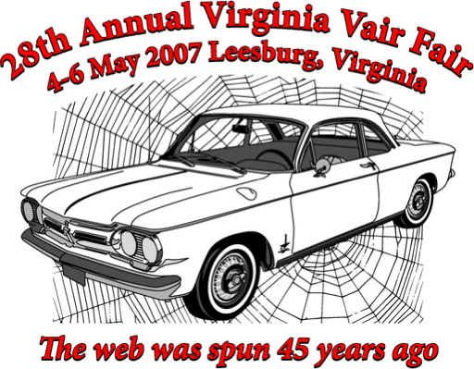

OWNER(S): ____________________________________________

HOMETOWN & STATE: __________________________________

YEAR & MODEL: _______________________________________

HISTORY: _____________________________________________

. _____________________________________________________

. _____________________________________________________

. _____________________________________________________

