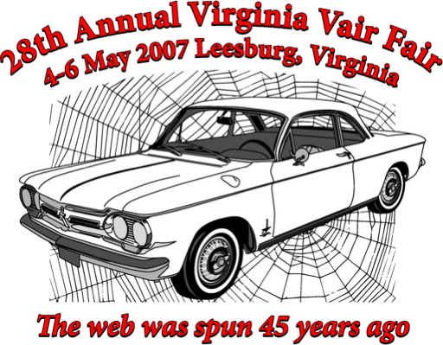

Early Open __________ Early Open __________

Early Closed __________ Early Closed __________

Spyder __________ Spyder __________

Late Open __________ Late Open __________

Late Closed __________ Late Closed __________

Forward Control __________ Forward Control _______
“Beater” __________ “Beater” __________

Early Open __________ Early Open __________

Early Closed __________ Early Closed __________

Spyder __________ Spyder __________

Late Open __________ Late Open __________

Late Closed __________ Late Closed __________

Forward Control __________ Forward Control_________

“Beater” __________ “Beater” __________

