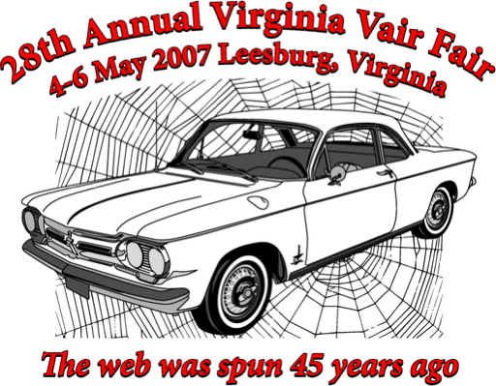

Model Car Competition Model Car Competition

15 and Younger __________ 15 and Younger _________

16 and Older __________ 16 and Older __________

Model Car Competition Model Car Competition

15 and Younger __________ 15 and Younger _________

16 and Older __________ 16 and Older __________

