To Whom It May Concern: July 1, 2013

We are the Bay State Corvair Club, with over one hundred active members. This year we are holding our Club’s 11th Fall Classic Car Show in Shelburne Falls, MA. Corvair owners and antique car buffs from all over the northeast typically show up for this event. Our club publishes an award winning monthly newsletter that rivals other automobile magazines in quality and in circulation. We also have an active website at www.baystatecorvairs.org which is visited by many of those curious about our unique automobile.

We are looking for any donations you would be generous enough to supply for our “Give-Away” Bags, any items for our raffles, or by sponsoring 1 Class of our trophies at $50.00 for a set of 3 Awards.

We would like ANY promotional items you could spare to add to the approximately 120 ‘Welcome Bags’ for this huge all Corvair event. Or perhaps you may have a larger item you could donate to us for our raffle table. Either way, any type of donation would be greatly appreciated and we would express our gratitude by publishing your business information in the show flyer, our newsletter and potentially our website.

Thank you very much .
for your consideration,

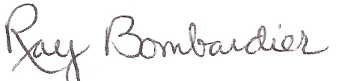
Ray Bombardier
President, Bay State Corvair Club
bomma@comcast.net
508-473-7026

