THE NORTH EAST CORVAIR COUNCIL
PRESENTS
The 35TH LIME ROCK
CORVAIR WEEKEND

Corvair Concours Show

When>>>Sunday, August 26 from 9 till 3

Where>>>Wake Robin Inn’s Front Lawn
106 Sharon Rd (Rte 41), Lakeville, CT 06039

Awards BBQ after Show
$19.95 per person/ $10.95 kids

AWARDS, PRIZES, RAFFLE

For Info, Contact
Bob Scheidel Robert.Scheidel@wiremold.com or Telephone (860) 233-6251 x3742
Or
Ron Manwaring ramanwaring@cox.net or Telephone (860) 621-7551

NECC TIME TRIALS

Monday, August 27

LIME ROCK RACE TRACK
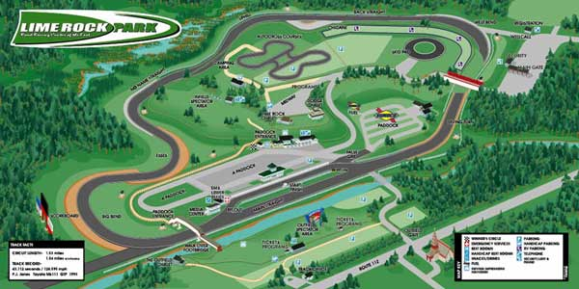
http://www.neccmotorsports.org/
http://www.limerock.com/

